Hands-on 1 – Creating a Spring Web Project using Maven

1. Project Execution and Output Verification

1.1 Maven Build Output
The project was packaged using the Maven build tool. Since the setup was completed on a personal network, the dependencies were fetched directly without routing through a corporate proxy firewall.
Terminal Build Command:
mvn clean package
Output:
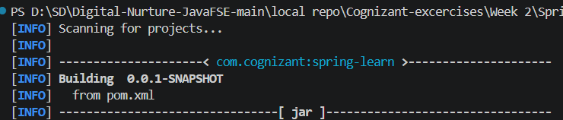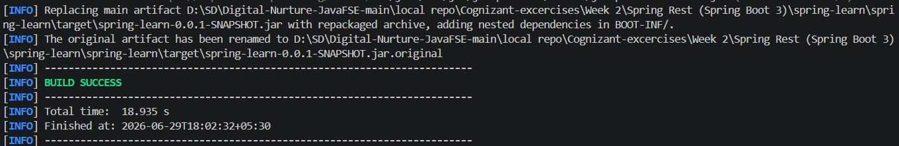

2. The Spring Boot Console Execution Logs
When you open SpringLearnApplication.java and click Run, your console will spin up the Spring Boot framework. This is where your custom logging statements prove the main() method executed correctly. What your console output should look like:
